BIOL 151 -- INTRODUCTORY ZOOLOGY
Spring 2013, Minot State University
Laboratory #6 & #7: Using morphometrics to interpret evolution in shape
-----------------------------------------------------
(Only the second week of this lab occurs in our actual lab meeting room. The first week can occur anywhere.)
-----------------------------------------------------

Interpreting evolution is based on the principle of “descent with modification.” What this results in is the similarity of closely-related species. Because of this result, one can examine any trait to test hypotheses of phylogeny. “Phylogeny” is the branch of biology that deals with the genealogical relationships of groups. When one makes a phylogeny, one is making and testing hypotheses about the genetic relatedness of two or more groups (e.g., populations, species, etc.). The two most easily used techniques for determining relationships of groups, i.e., making and testing a phylogeny, are (1) similarity and (2) parsimony methods.

In this two-week lab exercise, you will use the similarity method. You will use a morphometric technique to develop a phylogeny for three species of salamanders. (In our lab after this one, you will use a parsimony method to make and test a phylogeny for four or five different species of amphibians. For our similarity method this week, we will assess similarity using morphometrics. Using this technique will allow you to (1) test a phylogeny and then (2) interpret the evolution of shape differences among species in the context of the habitat differences of these species.

Morphometrics is the mathematical analysis of some aspect of body form. At its simplest, it means simply comparing a single variable and asking whether two forms differ (e.g., is one form bigger than the other?). At a more complex level, it means examining not only how individual features differ, but also how relationships among variables differ among groups (does a longer form also mean a thinner form?). When one examines relationships among measurements of a body, one is examining “shape.”

So long as the differences in body shape are due in part to genes, similarity in structure should indicate common descent, i.e., that two organisms that recently shared a common ancestor and therefore have had little time to experience genetic drift and natural selection of accumulated mutations that would lead to significantly different body shape. It logically follows that closely related species should exhibit more similarity in body shape than those that are less related.

The salamanders that you will examine are Desmognathus quadramaculatus (the blackbellied salamander), Ambystoma mavortium (the western tiger salamander) and Ambystoma maculatum (the spotted salamander). The first species is a member of the family Plethodontidae (the lungless salamanders); the second and third are members of the Ambystomatidae (the mole salamanders). The first species is a common species in the cool, fast-flowing streams of the southern Appalachian Mountains; D. quadramaculatus is stream-dwelling, and only rarely ventures away from the streams.

Of the other two species, A. tigrinum are common throughout North America, and this species has the single widest distribution of any salamander while A. maculatum is found commonly as well, but only in eastern North American deciduous forests. These two species spend their larval life in ponds, then undergo metamorphosis, leave these ponds for a fossorial (i.e., burrowing underground) lifestyle, and return to these same ponds for reproduction in early spring after the ice thaws and the ponds fill with snowmelt and/or spring rains.

------------------------------------------------------------------
METHODS – this is two week exercise. Only the second week occurs in the lab (Moore 210). The first is wherever you choose whenever you choose. The goal is the first week will allow you to understand clearly what you will do in your second week.

We need a methodology to measure shape. The simplest approach is to measure several variables (length, width, height), and divide by body size in order to correct for the species differences in body size. We do this because it makes little sense to compare the size of mouse tails with elephant tails, but it does make sense to ask “Do mice have longer tails, pound-for-pound, than elephants?”

All measurements, calculations and figures that follow from this lab exercise should be contained in your “Results” section. This lab has two basic sections: measurement and analysis.

WEEK 1 -- measuring boring household objects
1. Obtain three different objects of the same kind that can be held in your hand. Anything will do: three different coffee cups, three different glasses, three different forks, three different books, etc. Also obtain something to measure them with, e.g., ruler, tape measure.

2. For each object, measure four dimensions of your choice (e.g., height, length, circumference, diameter). Just choose three sensible dimensions that will be good descriptors of the shape of the objects. Make sure to use the same dimensions on each of your three cups, three forks, etc.

Make sure one you measurements is an estimator of the overall “object size”, e.g, cup height.

3. This means that you will have 12 data points: four measurements each of three different cups, forks, etc.

4. Download the speadsheet titled “Morphometrics Week 1.” Record your data in the appropriate spaces. (You will need to use a computer or device that can deal with Excel files.) Be sure to place the measurement for “object size” in the space for “Dimension D.”

Notice that as you enter your data, the entire spreadsheet will change as calculations are carried and graphs is constructed.

All the dimensions that you measured are represented on these graphs that are known as “bivariate plots.” These bivariate plots are visual descriptions of similarities and differences in shape of your three things. As you inspect these three graphs, ask your self several questions:

--Do any of these graphs indicate that the objects look different in shape?
--Do any of these graphs indicate that the objects look similar?
--Which dimension (or dimensions) appear to account for the differences?
--Can you connect the differences as they appear on the graphs with the actual appearance of these objects?

There is no writing or data reporting on this week’s component in lab. The intention is to prepare you for the work you do in lab in Week 2.

------------------------------------------------------------------

WEEK 2 -- measuring three species of salamanders
I. Measurements
You will measure your specimens with calipers. The calipers you will use are capable of measuring distances to the nearest 0.01 inch. While we prefer the metric system, our first calculations (see below) will remove the units (i.e., inches) and all traits will be placed in dimensionless unit.

You will be shown how to use the calipers in lab. However, Fig. 1 show how to read the calipers.

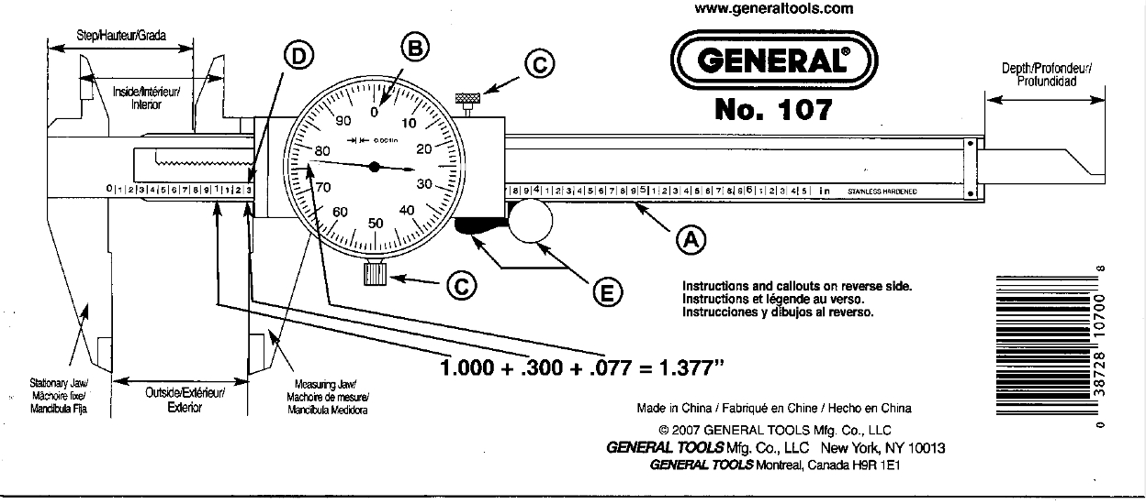

Fig. 1. – Instructions for reading dial calipers.

For four specimens for each species (i.e., 12 specimens in total), measure the following features (see Fig. 2):
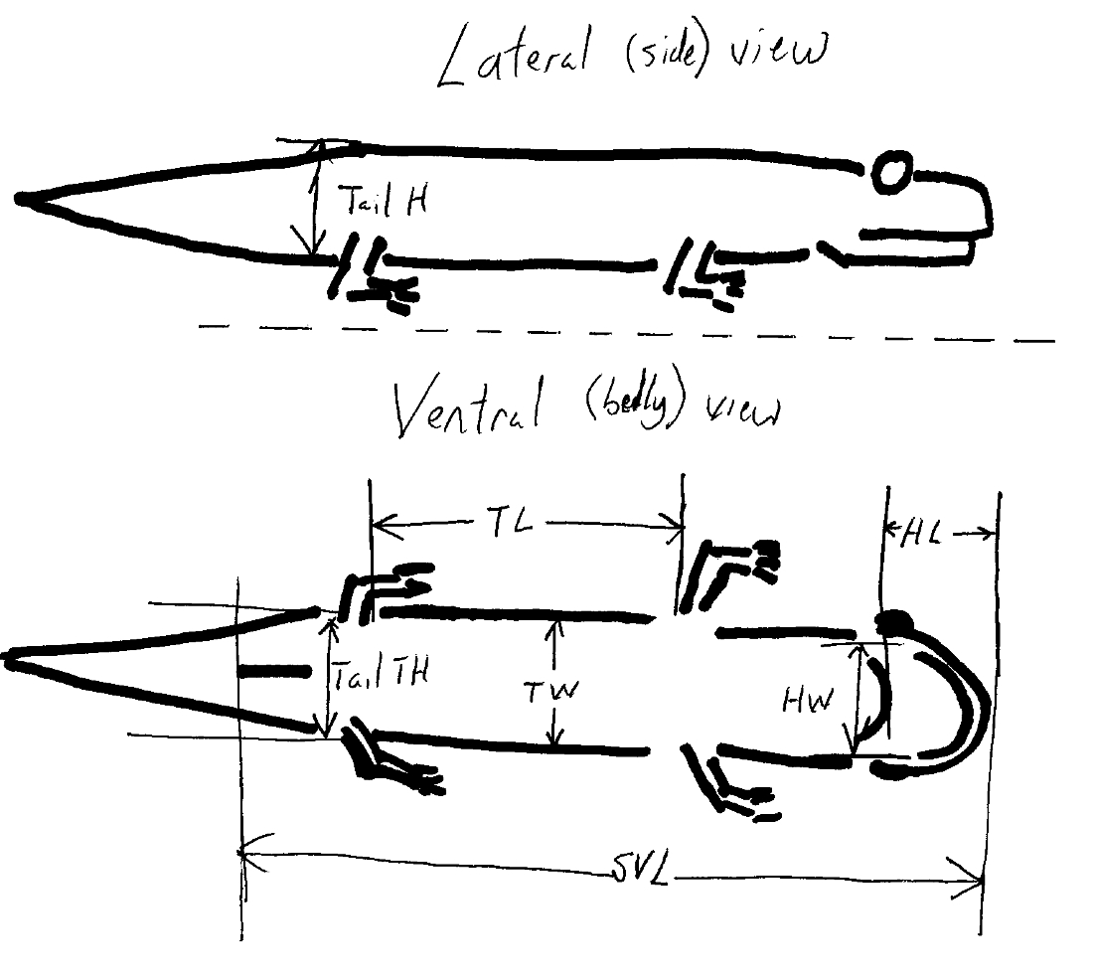

SVL (distance from the tip of the snout
to the posterior margin of the cloaca)
head width
head length
trunk length
trunk width
maximal tail height
tail thickness at point of maximal tail height

Fig. 2. -- Diagrammatic representation of body features measured for each salamander.

Record all your measurements in Table 1.

II. Calculations
All of the time-consuming calculations are accomplished by filling in the morphometrics spreadsheet available on my website.

Notice that as you fill in all values, that size-corrected values are calculated by dividing each trait by body size (i.e., SVL). These size-corrected values are then used for calculating three sets of “descriptive statistics”: means (for each of the six trait), variances (for each trait), and covariances (for each “trait pair”; there are 16 trait pairs).
Here are the equations for these descriptive statistics:
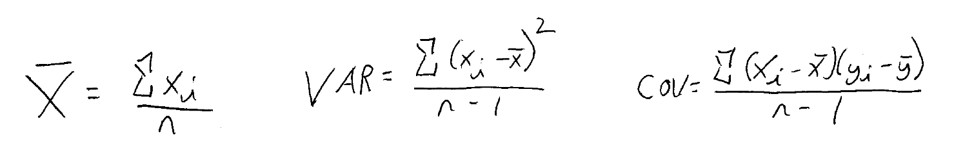
Try to notice just how similar these three statistics are: they are each a sum of something divided by how many of that something you are looking at. Their slight differences result in each statistic telling us something different about the traits being measured. These will be discussed in the next section.

[The variance should look familiar. Notice that the variance is just the square of SD (just as SD is the square root of variance).]

You won’t do all the calculations. These are done on the spreadsheet as you enter your raw data. Notice that the size corrected data are used to calculate means and variances and covariances for all the six size-corrected traits:

HW/SVL
HL/SVL
TL/SVL
TW/SVL
Tail H/SVL
and
Tail Th/SVL

You do not rewrite or reprint these data. You will use them to think about what “bivariate plots” to draw and interpret. A bivariate plot represents a pair of traits at once. In this survey, you are comparing species for six traits. With six traits, there are 15 possible combinations of trait pairs. You will need to examine the spreadsheet values of means, variances, and covariances so that you can wisely choose which bivariate plots you will present in your RESULTS section.

III. Preparation of figures
There are six time-consuming figures to prepare. You will prepare these six figures by hand.

Prepare what are known as bivariate plots. They look like this one (Fig. 3) that compares the heads and tails (and their relationship) for two kinds of mouse and one kind of elephant:

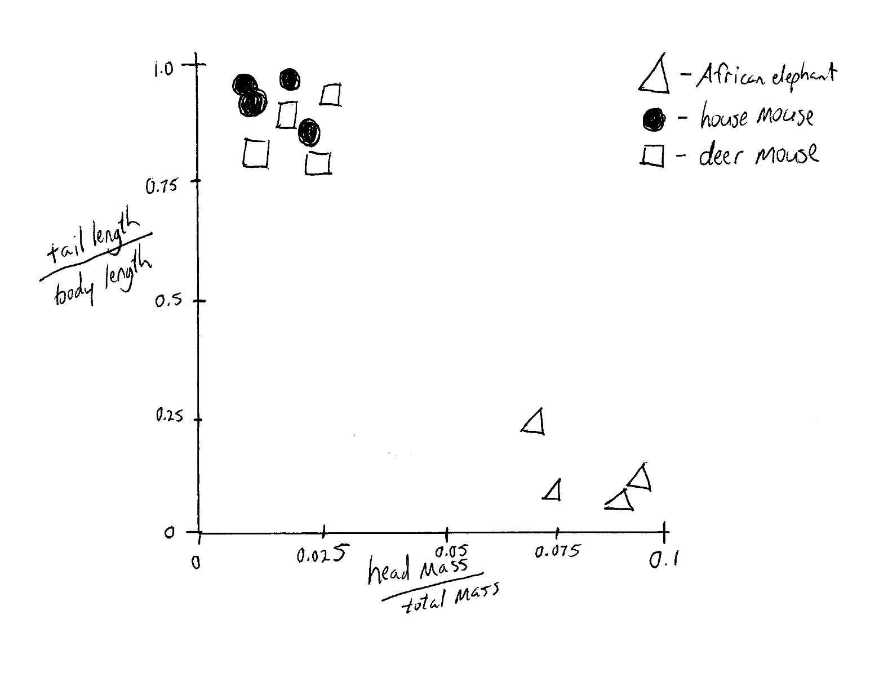

Fig. 3. -- Bivariate plot of head mass and tail length comparing shapes of two species of mouse with a species of elephant.

A bivariate plot contains all the information we need to describe the shape of an individual in regards to the two traits listed. For example, by drawing a polygon around each species’ points in Fig. 3 it can be used to show the average for the two traits (Fig. 4).

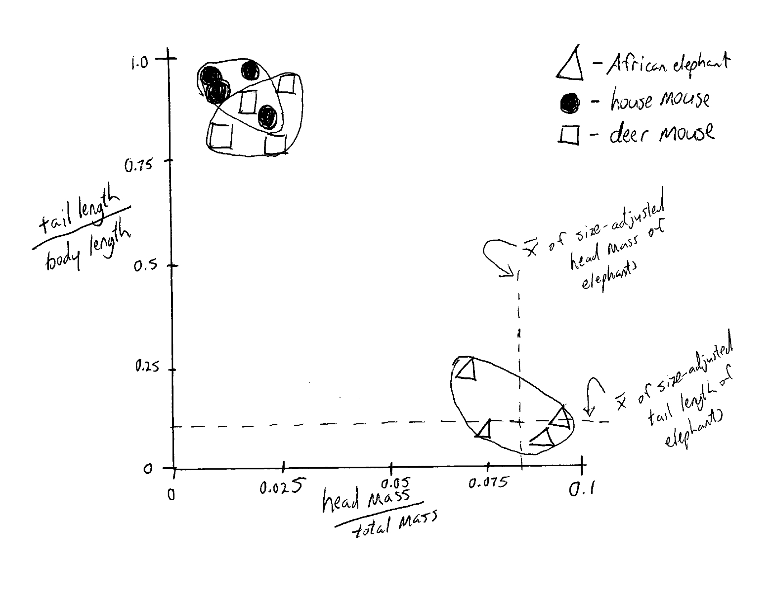

Fig. 4 -- Using a bivariate to demonstrate the means.

In addition, the plot can be used to demonstrate the variance (a statistic describing variation) for each trait (Fig. 5).

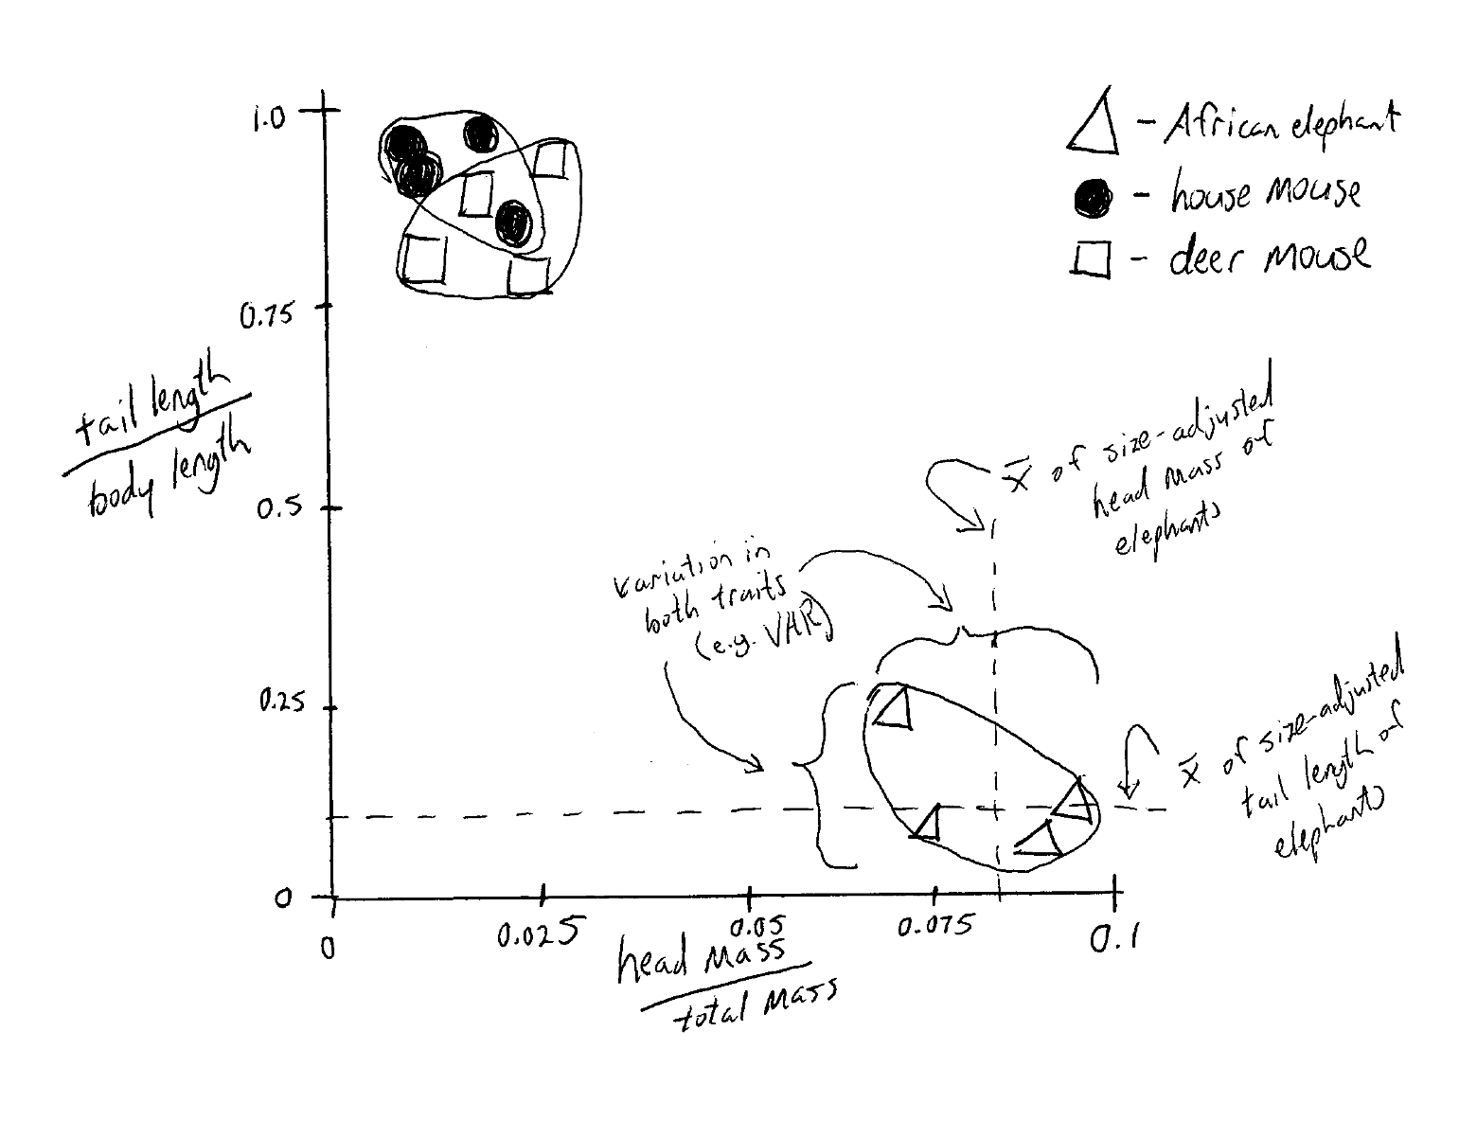

Fig. 5 -- Using a bivariate plot to demonstrate the variance of each trait for each species.
Finally, one can use the bivariate plot to demonstrate the covariance between the traits for each species (Fig. 6).

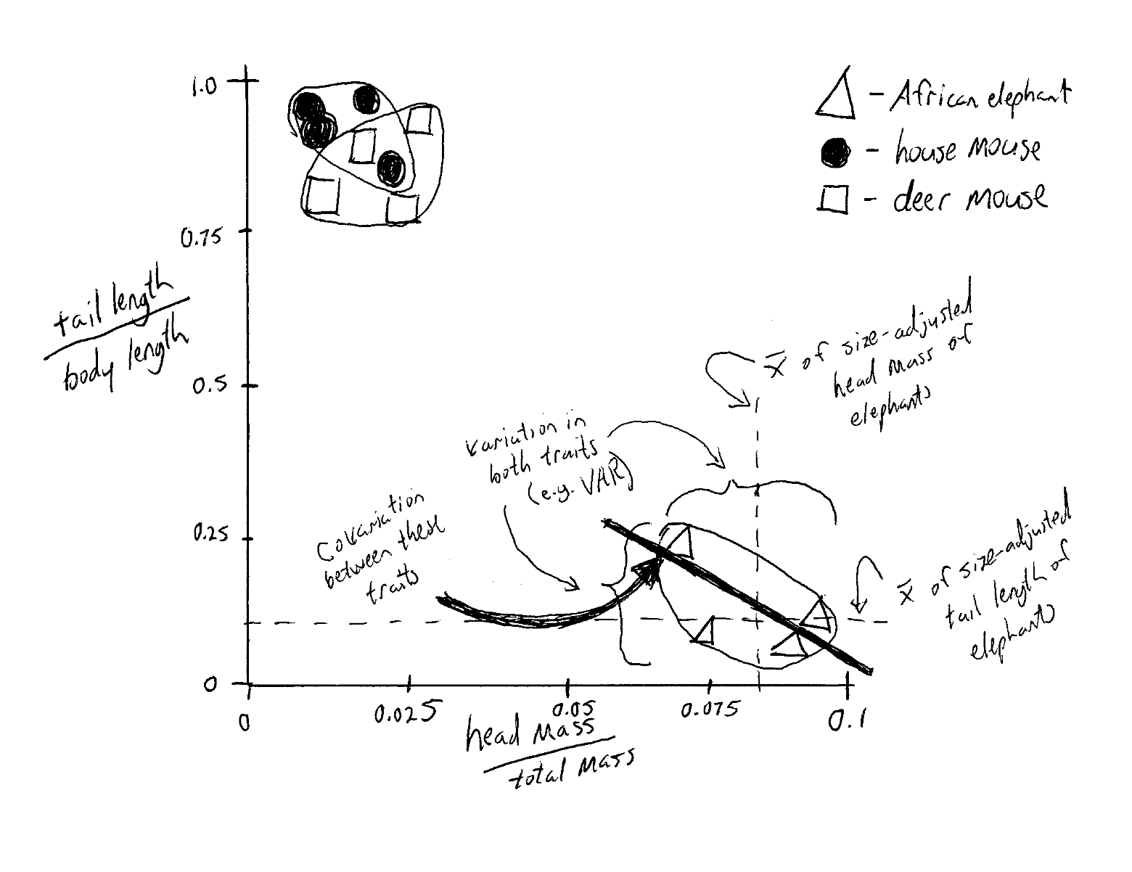

Fig. 6 -- Using the bivariate plot to demonstrate covariance between traits.

For example, the COV between head mass and tail length in elephants is negative (notice the negative slope of the line-of-best-fit). What this likely means, is that as elephants get larger, their heads gain size while their tails don’t get any bigger. A bull elephant need a big head for competing with other bull males; it’s tail doesn’t serve much purpose comparatively.

[A PowerPoint slideshow of these graphs is available on my website.]

WHAT TO PUT IN YOUR RESULTS SECTION
Prepare one of these bivariate plots. Study the spreadsheet means, variances, and covariances in order to decide which plot to make.

The intention of choosing a graph is to choose one that demonstrates that two of the species are similar and that the third is different. This means that two sets of your data will appear as “overlapping clouds” and the third “cloud” will be off by itself. This separation will show differences that are indicate relatedness and may be importantly related to adaptive differences (think about where these species live).

Was your hypothesis supported or rejected?

---------------------------------------
QUESTIONS TO GUIDE YOUR DISCUSSION SECTION.

Describe your inference and the support for it (be sure to tell which species appear more closely related based on your analysis). Make reference to your figures and your conclusion about your hypothesis (i.e., whether you rejected or fail-to-reject your hypothesis). According to the figure you chose and prepared, in what way did body shape differ among the species? Did it seem to be related in any way to the habitats in which these species are found?

You only need to turn in pages 9-10.

Name

HYPOTHESIS
Desmognathus quadramaculatus
Ambystoma maculatum
Ambystoma tigrinum

RESULTS

Table 1. – Morphometric data collected for four salamanders of three different species, for a total of 12 salamanders. D. q. = Desmognathus quadramaculatus; A. mac. = Ambystoma maculatum; A. tigr. = Ambystoma tigrinum.

SVL HW HL TW TL Tail H Tail Th

D. q.
1

2

3

4

A. mac
1

2

3

4

A. tigr.
1

2

3

4

RESULTS (continued)
(This is where your one figure will go, along with a fully written conclusion about the hypothesis.)

DISCUSSION
(Refer to the questions on the eighth page of this lab to help guide what you should be writing about.)

