Transcriptional Response of the Axolotl (Ambystoma mexicanum) to Cadmium Exposure.

Kenneth C Cabarle

INTRODUCTION
Cadmium is a widely distributed toxic metal with known mutagenic and carcinogenic activity. Cadmium is environmentally distributed by volcanic eruption and by anthropogenic activities. Cadmium becomes an environmental pollutant from industrial activities, as a residual of coal burning power plants and is found in high levels in tobacco smoke. One of the main sources of environmental cadmium is the disposal of Nickel Cadmium (Ni-Cad) batteries. Major concern over cadmium and other metal pollutants have focused on toxicity and cancer induction in humans (Godt et al.,2006). Cadmium and other heavy metals have also been the focus of environmental biomonitoring efforts which research levels of environmental contaminants and metals related sub-lethal effects in amphibians (Alloway, 1990, Heyer et al., 1993, Sparling et al., 2000, Adamas et al., 2001).
Two types of studies are prevalent: 1) studies that focus on quantifying bioaccumulated levels of a toxicant within organisims and 2) studies that focus on stress response signals in organisms exposed to environmental contaminants (Zettergren et al ., 1991, Hopkins et al., 1999, Goulet and Hontela, 2003, . Amphibians have been the focus for studies of environmental contaminants due to their continuing global declines and their bi-phasic lifestyle. Many amphibians spend part of their life in the water (larval stages) and part of their life on land this makes them suitable for searching for clues about sub-lethal toxicity. Additionally, amphibians have porous skin leading many to suggest that they would be able to show early warning signs of environmental degradation due to exposure (Kirby et al., 2010, James and Semlitsch, 2011).
The Axolotl (Ambystoma mexicanum) has been the focus of many studies and has been a model organism in early development, spinal-cord regeneration, and cellular re-modeling. The Axolotl is supported by genomic resources through Randall Voss’s lab at the University of Kentucky. Resources related to the Axolotl include an established EST database, web linked chromosome mapping and an Affymetrix salamander microarray which consists of Expressed Sequence Tag (EST) probes from A. mexicanum as well as probes from the related sister taxa the Tiger salamander (A. tigrinmum). These resources make it feasible to define the transcriptomic signature of salamanders in experimental treatments. Several recent studies have focused on the transcriptome response of salamanders to limb regeneration (Monaghan et al., 2009) exposure to an emerging pathogen (Cotter et al., 2009) and to test introgression of hybrid genes in an endangered species (Fitzpatrick et al., 2010).
In the wild the Axolotl is considered an IUCN Red List critically endangered species with limited distribution, drastically reduced population size and loss of preferred habitat. Habitat loss has been implicated in Axolotl declines as well as habitat degradation from anthropogenic activities, in particular pollution in remaining habitats for relict populations ( Zambrano et al., 2010). Studies that focus on the effect of environmental toxicants such as cadmium can help reveal possible effects of pollutants on natural populations. We studied sub-lethal effects of cadmium in laboratory exposures of Axolotls to elucidate pathways of stress that may be contributing to the loss of Axolotls in the wild.
In this study we applied an ecotoxicogenomics framework to test salamander response to a sub-lethal dose of cadmium at four time points. We hypothesized that transcriptional response would vary over the time course of the treatment and we expected to see stress response, cell signaling response, and apoptotic response similar to other studies. We also expected to see response in traditional metals responsive genes such as Metallothionien and Heat Shock Proteins. Other studies have observed transcriptome response to toxins, this is the first such study utilizing the salamander Affymetrix microarray to relate time point transcriptome response to a heavy metal toxicant.
MATERIALS AND METHODS
Axolotl Husbandry
Early blastula stage embryos of Ambystoma mexicanum were purchased from the Ambystoma Genetic Stock Center at the University of Kentucky http://www.ambystoma.org/AGSC/. Embryos were randomly placed into individual plastic Sterlite clear polypropylene containers in groups of ten. All individuals were housed in regulated growth chambers at 20⁰ C +/- 2⁰C (True Slide Glass Refrigerator Model GDM 45 with modified thermostat).
Embryos were feed fairy shrimp naupili (Artemia sp.) ad libitum until they were large enough to ingest black worms (Lumbricus sp.). The larvae were grown out to 75 days and then fasted for 2 days prior to cadmium treatment.
Cadmium Exposures
All salamanders were exposed to 50 parts per billion (ppb) cadmium chloride (CdCl_{2,} Sigma Scientific). Source water for treatments was verified to have no detectable traces of cadmium. Water at time of treatment had a ph. Of 8.7 and a hardness of 27 parts per million total dissolved solids. Larvae were exposed to CdCl₂ at 50 ppb in aqueous solution and checked at timed intervals. Treatment groups were 0 hours treatment (control), 1 hour, 12 hours, and 24 hours. At each specific time interval all larvae in a time treatment were euthanized by immersion in a 10% solution of Tricaine Methanesulfonate (MS222, Sigma Scientific). All larvae were checked for responsiveness and then given an extra 10 minutes in MS222 to assure death. Liver tissue from all individuals in each treatment were dissected and preserved in cryovials in RNAlater RNA stabilizing solution in an ultra-cold freezer (-80). Tissues were then sent next day air to the microarray core facility at the University of Kentucky. The core facility performed RNA extractions, quality assessment and hybridizations to the microarrays.
Microarray Analysis
A first generation custom Ambystoma Affymetrix microarray chip was utilized to generate candidate gene lists for possible cadmium responsive salamander bio-markers. The design of this chip is described by Putta et al., (2004) and Smith et al., (2005). Liver tissues of A. mexicanum larvae exposed to 50 ppb CdCl₂ at 1hour, 12 hours, and 24 hours were analyzed at the Laboratory of Dr. Randal Voss at the University of Kentucky in cooperation with the University of Kentucky microarray core facility.
Two sets of six chips, twelve technical replicates, were hybridized on separate dates (Twelve microarrays total). Five individual biological samples were pooled for each of the microarray chips for each of the treatments assessed (50 ppb CdCl₂ at control (0 hours), 1 hour, 12 hours, and 24 hours) for a total of n=60 biological replicates. Initial quality control was performed at the UK microarray core facility. RNA quality and quantity were determined using and Agilent 2100 Bioanalyzer. Inspection of a Principle Components Analysis (PCA) determined that variance between each of the chip set runs was large so we evaluated the microarrays with two types of statistical analyses as described in the statistics section. Genes that displayed differential transcription beyond 2 fold and at an α < 0.05 were investigated as potential candidate biomarkers for cadmium exposure.
Statistical Analysis
Transcriptional values from the microarrays were normalized in the FlexArray software package with the RMA algorithm from the “affy” package for Bioconductor (Irizarry et al., 2003, Blazejczyk et al., 2007). Cyber-T (Baldi and Long, 2001) statistical analysis and Empirical Bayesian analysis (Smyth, 2004, Cui et al., 2005, and Huang and Liu, 2010) distinguished highly up and down regulated gene lists. In all analysis cut-offs for significance were genes that were beyond 2 fold expression and had a statistical significance of p < 0.05. Candidate genes were blasted for homology in the NCBI non-redundant database and categorized for gene ontology groups.
RESULTS
Microarray raw images were imported into the FlexArray software package and assessed for intra and inter array variance. Boxplots of all raw intensities showed no major outlier arrays. PCA showed a higher variance in the second technical run (microarrays for the 1 hour and 24 hour treatments). All microarrays were normalized using the RMA algorithm and then treated to two statistical analyses. A conservative analysis compared the two technical replicates separately from each other. The 0 and 12 hour treatment means were compared by Cyber-T test and the 1 hour and 24 hour treatments were compared, these comparisons were then matched and evaluated for similarities. The second statistical analysis (non-conservative) compared all time points to the 0 hour control group in an Empirical Bayesian analysis. In all comparisons statistical significance cutoff was beyond 2 fold expression with an α < 0.05.
In both statistical tests threshold cutoffs reduced the gene probe targets from ~ 4500 down to about 100 in the conservative comparison and to around 300 gene probes in the non-conservative analysis.
Cyber-T Statistical Tests (Conservative statistical analysis)
Cyber-T statistical analysis yielded two differentially expressed gene lists. Comparison of control X 12 hour (same technical replicate) microarray chip sets of CdCl₂ exposure produced a set of 33 differentially expressed genes ( Table 1). 14 down regulated genes and 19 up regulated genes were found to be differentially expressed (Figure 1 a). Comparison of the 1hour X 24 hour (same technical replicate) microarray chip sets yielded a set of 60 differentially expressed genes ( Table 2). 26 down regulated genes and 34 up regulated genes were found to be differentially expressed (Figure 1 b). Gene lists from both chipsets were matched to the most current ambystoma annotation library. The control X 12 hour chipset included 9 down regulated genes with known gene homology and 5 down regulated genes of unknown function. Up regulated genes in this chipset were represented by 10 genes with known function and 9 genes with unknown function.
The 1 hour X 24 hour chipset included 10 down regulated genes with known gene homology and 16 genes with unknown function. Up regulated genes in this chipset were represented by 17 genes with known function and 17 genes with unknown function.
Empirical Bayesian Statistical Analysis
Empirical Bayesian analysis produced a gene list for each time point relative to control arrays. Three gene lists were developed for each of the time points. Assessment of the 1 hour time point yielded a list of 81 differentially regulated genes, 21 genes were found to up-regulated and 60 genes were found to be down regulated (Table 3). 28 of the genes at the 1 hour time point have no known homology. The 12 hour assessment produced a list of 29 differentially expressed genes (Table 4). 11 genes were found to be down regulated and 18 genes were found to be up-regulated. 16 genes at the 12 hour time point have no known homology. The 24 hour assessment produced a list of 163 differentially expressed genes. 81 genes were found to be down regulated and 82 genes were found to be up-regulated ( Table 5). 65 genes at the 24 time point showed no known homology.
Gene Ontology
Gene ontology and functional gene groups were explored with the use of GENECODIS software. GENECODIS is a web-based tool for finding significant concurrent annotations in gene lists (Carmona-Saez et al., 2007, Nogales-Cadenas et al., 2009). The most current ambystoma annotation file and both chipset gene lists were queried for gene ontology groups. Additionally, gene names from the annotation were queried in the Database for Annotation, Visualization and Integrated Discovery (DAVID ) v6.7. GeneMania (Warde-Farely et al., 2010) was used to visualize and predict regulatory network relationships in gene lists in this experiment. GeneMania also provided gene functions in cellular and sub-cellular networks. GeneMania produced the annotation that was the easiest to visualize and interpret and GeneMania GO terms are presented here.
GO annotation in GeneMania using Cyber-T analysis of the 0 hour x 12 hour comparison produced the following functions:
Cellular response to cytokine stimulus, cellular response to type I interferon, cytokine-mediated signaling pathway, regulation of cell migration, regulation of cell motility, regulation of cellular component movement, regulation of locomotion, response to cytokine stimulus, response to type I interferon, and type I interferon-mediated signaling pathway.
GO annotation in GeneMania using Cyber-T analysis of the 1 hour x 24 hour comparison produced the following functions:
Cellular response to cytokine stimulus, cellular response to type I interferon, cytokine-mediated signaling pathway, regulation of cell migration, regulation of cell motility, regulation of cellular component movement, regulation of locomotion, response to cytokine stimulus, response to type I interferon, and type I interferon-mediated signaling pathway.
GO annotation in GeneMania using Empirical Bayesian analysis for Treatment at 1h hour exposure at 50 ppb Cadmium produced the following functions:G1/S transition of mitotic cell cycle, DNA replication,M/G1 transition of mitotic cell cycle,cell cycle checkpoint, regulation of cell cycle arrest, DNA strand elongation involved in DNA replication, DNA strand elongation ,DNA-dependent DNA replication, S phase of mitotic cell cycle, S phase, nuclear chromosome part, regulation of transcription involved in G1/S phase of mitotic cell cycle, nuclear chromosome, chromosome segregation, spindle pole,regulation of mitotic cell cycle, spindle organization, spindle, G2/M transition of mitotic cell cycle, sister chromatid segregation, regulation of G2/M transition of mitotic cell cycle phosphatidylinositol-mediated signaling, mitosis, nuclear division, inositol lipid-mediated signaling, ATP-dependent DNA helicase activity, organelle fission, M phase of mitotic cell cycle DNA-dependent ATPase activity, microtubule-based process, mitotic spindle organization DNA helicase activity, mitotic sister chromatid segregation, purine NTP-dependent helicase activity, ATP-dependent helicase activity, microtubule cytoskeleton organization, regulation of chromosome segregation, positive regulation of cell cycle process, regulation of interphase of mitotic cell cycle, helicase activity, mitotic cell cycle checkpoint, DNA recombination, regulation of cell division, condensed chromosome, ATPase activity, coupled mitotic recombination, mitochondrial membrane, anaphase-promoting complex-dependent proteasomal ubiquitin-dependent protein catabolic process, and condensed nuclear chromosome.

GO annotation in GeneMania using Empirical Bayesian analysis for Treatment at 12 hours exposure at 50 ppb Cadmium produced the following functions:Regulation of locomotion, ligand-dependent nuclear receptor activity, positive regulation of locomotion, regulation of cell motility, positive regulation of cell motility, regulation of cellular component movement, regulation of cell migration, positive regulation of cellular component movement, positive regulation of cell migration, and regulation of transcription from RNA polymerase II promoter by nuclear hormone receptor.

GO annotation in GeneMania using Empirical Bayesian analysis for Treatment at 24 hours exposure at 50 ppb Cadmium produced the following functions:
Tetrapyrrole metabolic process, tetrapyrrole binding, spindle pole, spindle, ribosome binding, regulation of mitotic cell cycle, regulation of interphase of mitotic cell cycle, regulation of G1/S transition of mitotic cell cycle, positive regulation of cell cycle process, porphyrin-containing compound metabolic process, organelle fission, nucleobase-containing small molecule interconversion, nuclear division, mitotic cell cycle G1/S transition checkpoint, mitotic cell cycle checkpoint, mitosis, microtubule-based process, M phase of mitotic cell cycle, G1/S transition of mitotic cell cycle, and G1/S transition checkpoint.

DISCUSSION
The conservative statistical assessment of these microarrays points to several target gene pathways. Most importantly we see a signal of Early Immediate Genes, in particular a signature of the AP-1 network being differentially expressed in reaction to cadmium exposure. By 12 hours we see a signature of JUN, FOS and ATF all leading to matrixmetallopeptosidase (MMP) signaling outside the cell to initialize the induction of stress response genes. (network map Fig.4 and 5) By 24 hours signaling pathways have moved away from the strong early immediate response to stress response, DNA repair and ROS responsive genes.
The EB (Non-conservative) statistical analysis also shows a progression of patterned signaling that starts at 1hr with the induction of several different types of Kinases (including differential expression of Aurora kinase a and b), cell cyclins, regulation of apoptotic pathways, and the differential expression of many genes related to intracellular signaling, cell motility and cell cycle progression (Figures 6, 7 and 8).
Cyber-T analysis pathways:
The conservative assessment gene lists were compared to produce a venn diagram showing shared and distinct genes. This comparison revealed 8 shared gene probes in this analysis, Fig 2. Cyber-T testing produced 8 genes that were differentially regulated in both comparisons. Four of these genes produced no known homology. Four known genes were differentially expressed these genes are serum/glucocorticoid regulated kinase, jun B proto-oncogene, WAP four-disulfide core domain 5 precursor, and cyclin-dependent kinase inhibitor 1B, (Figure 9).
Serum glucocorticoid regulated kinase is a gene that has been shown to promote malignant growth in myeloma cells; it has also been shown to be important in activating certain potassium, sodium, and chloride channels in response to osmotic stress in hepatocytes (Snyder et al., 2002, Seebohm et al., 2007). Active channel transport across the cellular membrane and the occupation and overload of these channels is one of the direct mechanisms of cadmium toxicity at the cellular level.
Jun B has been shown to be both apoptotic and anti-apoptotic in response to cell environment. This gene is important to the signaling of AP-1 in regenerating liver tissue (Hsu et al., 1992). Jun B is also implicated in the onset of several human cancers. Here Jun B was differentially down regulated which indicates a repression of Jun B. Jun B has been shown to be anti-apoptotic in hepatocytes and to be a signaler of normal cell cycle progression in hepatocytes. There is still some grey area here as the specific signaling of Jun B is not a standalone signal and the expression or down regulation of Jun B’s signaling role is dependent on the signals from the other Jun species in the AP-1 pathway. In this case Jun B down regulation may allow the cells to initiate apoptosis in response to Reactive Oxygen Species (ROS) and cadmium induced cellular stress.
WAP four-disulfide core domain 5 precursor is a protease inhibitor. Typically protease inhibitors are expressed in reaction to cellular threat from viruses. In this analysis WAP was highly up-regulated and was up-regulated at 12 and 24 hours in the EB analysis and indicates a steady signal within the extracellular matrix to provide protection against cadmium induced stress signal mimicking viral intrusion. Additionally, this gene provides basal cellular protection from degradation of proteins needed for normal cell signaling and function.
Cyclin-dependent kinase inhibitor 1B (CDK) is highly up regulated in this comparison and is also up-regulated at 12 and 24 hours in the EB analysis. Overexpression of CDK can cause cells to arrest in G-1 phase of cell cycle growth. This may be in response to cadmium induced cellular stress and may lead to the initiation of cellular apoptotic pathways leading to cell quiescence and programmed cell death. For the CDK gene we see fewer transcripts at 24 hours indicating a lessening of cell cycle suppression as time progresses in response to cadmium treatment.
Empirical Bayesian analysis pathways:
The non-conservative assessment gene lists were compared to produce a venn diagram showing shared and distinct genes (Fig 3). In this assessment two genes were found in all time points. One of these gene probes showed no known homology the other gene probe was homologous with Mannose-6-Phosphate Receptor Binding Protein 1 (MPR). This gene is important in the signaling for the construction of lysosomes in the golgi complex and was up-regulated at all time points. MPR is important in developing and maintaining endosomes and ultimately facilitates vesicle transport at the cellular level. MPR in this analysis shows an increase in up-regulation at all time points and may represent increased intra and extra cellular transport of cellular complexes in response to cadmium scavenging. It may also be indicative of increased cellular activity in response to general cellular stress and ROS stress response.
54 genes were shared between the 1 hour and 24 hour time points. Nine genes were shared between the 12 and 24 hour time points. Five of these genes showed no known homology. The other four genes are MPR, serum/glucocorticoid regulated kinase, WAP four-disulfide core domain 5 precursor, and cyclin-dependent kinase inhibitor 1B. Three of these gene probes were shared in the conservative analysis with Jun B being replaced by MPR in this analysis.
The comparison of 1hour to 12 hours yields the two genes shared by all three time points, one unknown and Mannose-6-Phosphate Receptor Binding Protein 1.
Comparison of the 1hour to 24 hour treatment shows 52 shared genes. Of the 52 there were 17 gene probes with no known homology.
When we look at each of these time points individually we begin to see a pattern of gene signal at the cellular level that seems to move from initial normal cell progression to a signaling of stress response from within the cellular matrix to outside the cell. This signal then begins to turn at 12 hours from normal cellular function to full on cellular stress. We see a cycling of stress response and DNA repair genes at 24 hours. The cut-off or threshold here is somewhere between 1 and 12 hours, a more detailed picture would be exposed by half hour intervals for microarrays, regardless the signal at the cellular level progresses from normal and limited stress response at 1 hour to many different genes at 12 and 24 hours that are the initial stress response signal to genes related to normal cell cycle and cellular progression. Several genes and groups of genes that control and signal normal cellular division are up-regulated at 1hour. For instance we see an up regulation of aurora kinases, an up-regulation of cyclin B3, up-regulation of histones, and an up-regulation of MCM 4, 6 and 7. All of these genes are important to the initiation of cellular, DNA, or genome replication (Figures 10 and 11).
In addition to cellular replication we also see several genes that are known to respond to stress and to signal basic cellular rescue functions or apoptotic pathways. Genes such as Cytochrome C, Cytochrome C somatic, Cold Inducible RNA Binding Protein, Cold Shock Domain E1 RNA Binding, Guanine Nucleotide Binding Protein Like 2, Isopentyl-Diphosphate Delta Isomerase 1, karyopherin alpha 2, KIAA0101, Kinesin Family Member 1, Trypsin 1, Solute Carrier Family 25, and Transglutamase 1 are all examples of genes that have been implicated in the initiation, regulation and signaling of stress response or apoptotic pathways. Cytochrome C overexpression has been shown to be pro-apoptotic ( Chandra et al., 2002).
Most genes showed a progression of signaling that remained constant over the time treatments, for example Mannose-6-Phosphate Receptor Binding Protein 1 shows a steady up-regulated signal at all time points, the aurora kinases show up-regulation from 1 to 24 hours. One gene however, switched regulation pattern. Protease, Serine, 1(Trypsin 1) is highly down regulated at 1hour and switches to being highly up-regulated by 24 hours. Trypsin 1 is a trypsin family form of serine protease which in this case may be signaling the onset of transcription factors related to pro-apoptotic genes or signaling the down regulation of transcription factors in anti-apoptotic genes. This may be a signal to coordinate cellular immune response.
Several genes responding to cadmium exposure have been implicated in the onset of oncogenisis or are important in guiding cellular response to cancer like signaling. Guanine Nucleotide Binding Protein Like 2 (nucleolar) is an anchor of certain adapter proteins which recruit signaling pathways leading to the regulation of apoptosis in lymphocytes. In this instance we see an increasing signal of down regulation at 24 hours. Karyophin Alpha 2 (RAG 1) is up regulated at 1 hour and at 24 hours and has been implicated in immune response related to hepatocellular carcinoma (Yoshitake et al,. 2011). The gene KIAA0101 and Kinesin Family Member C1are both up-regulated at 1 hour. KIAA0101 has been shown to be overexpressed in pancreatic cancer cells (Yu et al., 2001). Kinesin Family Member C1 has been isolated to a region of the MHC (Ando et al. 1994). At 24 hours these two genes are not found in the highly differentially expressed genes. Two closely related genes KIAA0020 and Kinesin Family Member 21A appear highly down regulated at 24 hours. There is no indication of related response here but it is interesting that these closely related genes switch from being highly up-regulated to being highly down regulated.
Two Histones, H2A Histone Family Member J and Histone 2 H2AC show a strong signal of up-regulation and this signal is maintained to 24 hours which may indicate a strong signal of cellular differentiation and cellular DNA replication. Two membrane transporters, Solute Carrier Family 25 and Solute Carrier Family 7 show up-regulation to 24 hours indicating a strong signal of intra/extracellular transport across cell membranes. This fits the ability of cadmium to inundate active trans-membrane transport channels. We also see a down regulation of Ubiqutin at 1 hour and at 24 hours. This down regulation may indicate a slowing of the cellular scavenging of cadmium and ROS species. We might expect to see a strong signal of up-regulation in ubiqutin in response to increased cellular scavenging in relation to increased cellular burden however, in this case it seems that something may be blocking ubiqutin signal. Additional focus on the ubiqutin baseline and response to cadmium is needed.
Two gene families that we expected to be responsive in this experiment, Metallothionein and Heat Shock Proteins, did not show differential expression in this experiment. Both of these genes have been shown to be responsive to metals exposure and it is surprising that they did not show response. This does not mean that they are not responsive to cadmium in salamander tissue but does indicate that salamanders may not have the same timed response as other vertebrate species or that the cadmium dosage was not high enough to initiate a visible signal in these genes. Q-PCR of these two genes was parallel to the response of the microarrays.
Candidate Genes
Within this experiment there are many genes that showed response to cadmium. However, we wanted to make sure that candidates would be responsive at multiple time points and would also be good integrators of cadmium induction. Network analysis of gene lists utilizing standardized gene names in GeneMania revealed that the AP-1 regulatory pathway was responsive in both technical replicate sets in the conservative (Cyber-T) statistical analysis. This pathway regulates cell cycle and cell fate dependent on the heterodimerazation of the protein and dependant on environmental circumstances. Cell signal and transcription response related to the AP-1 signaling pathway has been shown to be anti-apoptotic in hepatocytes when the signaling involves Jun-B. Differential Jun-B expression has also been shown to inhibit mitochondrial stress and cytotoxicity as a part of the AP-1 pathway (Hess et al., 2004). Jun-B inhibits or mitigates apoptotic cell cycle progression in response to ROS (Son et al., 2010). To this end targets have been chosen from the most conservative statistical analysis. The targets are genes related to the induction of the Immediate Early Genes several of which make up the regulatory pathway for the AP-1 transcription factor.
Genes within the AP-1 pathway are current targets for biomarker analysis. These genes include the genes Jun B Proto-Oncogene, HES1(Heme Oxygenase Decycling 1), MMP-9 (Matrix Metallopeptosidase 9), and CDKN1-B (Cyclin Dependant Kinase Inhibitor 1-B). JunB Proto-Oncogene, HES1(Heme Oxygenase Decycling 1), MMP-9 (Matrix Metallopeptosidase 9), and CDKN1-B (Cyclin Dependant Kinase Inhibitor 1-B) have been shown to be highly differentially expressed in microarray analysis in both limb regeneration and Ranavirus (ATV) infections utilizing the same microarray (Amby 001) platform at the same facilities which analyzed the microarray data sets in this experiment (Cotter et al., 2008). Table 6. shows primer sets for current Q-PCR candidate genes.
Additionally, the genes SGK1(Serum Glutocorticoid Regulated Kinase), S100 Calcium Binding Protein P, Metallothionein Isoform 1(MET-1), Heat Shock Organizing Protein (HSP-70/90), and the housekeeping genes Beta Actin and GAPDH will be tested and optimized for Q-PCR assay. Genes with basal expression in the liver and mitochondrial genes were excluded as possible candidate genes.
Conclusion
We exposed Axolotls to low dose cadmium exposure and measured transcriptome response at 0, 1, 12, and 24 hour time points. Statistical analysis of these microarrays implicated the AP-1 transcription factor as responsive. Gene expression patterns showed an early response of cell differentiation, normal cell cycle progression and the initiation of genes related to stress response and extracellular scavenging. Genes related to DNA replication and genome replication were up-regulated at the 1 hour time point. In this experiment it appears that several gene pathways that might be expected to be up-regulated were not ( MET and HSP). Some genes that we might expect to see up-regulated were down regulated ( Ubiquitin, Cold Shock Domain Containing E1, RNA Binding).
Major groups of genes that we did see up-regulated were Cytochrome C Oxidase, Cytochrome C Somatic, the Aurora Kinase Family, several MCM genes, Cyclin Dependant Kinase Inhibitor 1B, Heme Oxygenase and Serum/Glucocrticoid Regulated Kinase. Many genes that were differentially expressed have been implicated in onset of apototic pathways and or cancers. In particular the overall response contains many genes related to abnormal cell growth in hepatocytes, pancreatic cancers, lymphocytic cancers, and regenerating lymphocytes.
Cadmium at the cellular level appears to do the following: cause differential and abnormal signaling of normal cell progression, initiate Immediate Early Gene response through the AP-1 pathway, block or inundate active membrane transport channels, interrupt many normal pathways, instigate the cellular stress response through the development of excess ROS species, initiate the regulation of pro-apoptotic pathways and down regulate signals that would signal normal cell progression leaving cells stuck in the G1 phase which may initialize the onset of pro-apoptotic signal leading to additional cell death within liver tissue.
This experiment shows the value of genomic resources in model organisms. The findings facilitate the study of candidate genes in natural populations. In particular the findings from this study and other studies can lead to a greater understanding of toxicant effects at the cellular level and may help in future studies of the Axolotl which has current status as a globally critically endangered species in the wild. These findings can also be applied to the Axolotls sister taxa, the Tiger Salamander complex. We can also hope that others may take this information and experimental approach and apply it to other species in the Ambystoma clade. The future of this research will test the response of genes found in this experiment in natural populations of Tiger Salamanders to test the applicability of Tiger Salamanders as an indicator of environmental conditions at the local landscape level.

LITURATURE CITED
Adamus, P., Danielson, T.J., and Gonyaw, A., 2001. Indicators for Monitoring Biological Integrity of Inland, Freshwater Wetlands A Survey of North American Technical Literature (1990-2000), Office of Water, Office of Wetlands, U.S. Environmental Protection Agency, Washington, DC. EPA-843-R-01-Fall 2001
Alloway BJ., 1990. Cadmium. In: Alloway BJ, editor. Heavy metals in soils. New York:Wiley and Sons, Inc. p 100-21.
Baldi P, Long AD. 2001. A Bayesian framework for the analysis of microarray expression data: regularized t-test and statistical inferences of gene changes. Bioinformatics 17, 509–519.
Blazejczyk, M., Miron, M., and Nadon, R., 2007. FlexArray: A statistical data analysis software for gene expression microarrays. Genome Quebec, Montreal, Canada, URL http://genomequebec.mcgill.ca/FlexArray
Carmona-Saez P, Chagoyen M, Tirado F, Carazo JM, Pascual-Montano A: GENECODIS: A web-based tool for finding significant concurrent annotations in gene lists. Genome Biology 2007 8(1):R3 [ PubMed ]
Chandra, D., Liu, J.W., Tang, D.G., 2002. Early mitochondrial activation and cytochrome c up-regulation during apoptosis. J. Biol. Chem. 277, 50842–50854.
Cotter J.D., Storfer A., Page R.B., Beachy C.K., Voss S.R.,2008. Transcriptional response of Mexican axolotls to Ambystoma tigrinum virus (ATV) infection. BMC Genomics. 2008; 9: 493.
Cui XQ, J. T.G. Hwang, J. Qiu, N.J. Blades and G. Churchill (2005) Improved statistical tests for differential gene expression by shrinking variance component estimates. Biostatistics Jan. 6(1):59-75. [PMID: 15618528]
Durbin, B., Rocke, D. (2004). Variance StabilizingTransformations for Two-Color Microarrays. Bioinformatics. 20, 660-667.
Fitzpatrick BM, Smith JJ, Voss SR, Shaffer HB. 2010. Rapid spread of invasive genes into a threatened native species. PNAS 107:3606-10.
Godt, J., Scheidig, F., Grosse-Siestrup,C., Esche, V., Brandenburg, P., Reich, A., and David A Groneberg, 2006. The toxicity of cadmium and resulting hazards for human health. Journal of Occupational Medicine and Toxicology 2006, 1:22.
Goulet, BN, Hontela A. 2003. Toxicity of cadmium, endosulphan, and atrazine in adrenal steroidogenic cells of two amphibian species, Xenopus laevis and Rana catesbeiana. Env. Tox. Chem. 22:2106-2113.
Hess J, Angel P, Schorpp-Kistner M (2004). "AP-1 subunits: quarrel and harmony among siblings". J. Cell. Sci. 117 (Pt 25): 5965–73.
Heyer, W.R., M.A. Donnelly, R.W. McDiarmid, L.C. Hayek, and M.S. Foster (editors). 1993. Measuring and monitoring biological diversity: standard methods for amphibians. Smithsonian Institution Press,Washington and London.
Hopkins, WA, Mendonca, MT, Congdon, JD. 1999. Responsiveness of the hypothalamo-pituitary-interrenal axis in an amphibian (Bufo terrestris) exposed to coal combustion wastes. Comp. Biochem. Physiol. C. 191-196.
Hsu JC, Bravo R, Taub R (1992). "Interactions among LRF-1, JunB, c-Jun, and c-Fos define a regulatory program in the G1 phase of liver regeneration". Mol. Cell. Biol. 12 (10): 4654–65. PMC 360392. PMID 1406655.
Hwang, J. T. G. and Liu P. (2010) Optimal tests shrinking both means and variances applicable to microarray data analysis, Statistical Applications in Genetics and Molecular Biology, 9:1 article 36
Irizarry RA, Hobbs B, Collin F, Beazer-Barclay YD, Antonellis KJ, Scherf U, Speed TP. 2003. Exploration, normalization, and summaries of high density oligonucleotide array probe level data. Biostatistics 4, 249–264.
James, S.M., and R.D. Semlitsch. 2011. Terrestrial performance of juvenile frogs in two habitat types after chronic larval exposure to a contaminant. Journal of Herpetology 45:186-194.

Kerby JL, Richards-Hrdlicka, KL, Storfer A, and D. Skelly. (2010) An examination of amphibian sensitivity to environmental contaminants: are amphibians poor canaries?, 60-7. In Ecology letters 13
Monaghan JR, Epp L, Putta S, Page RB, Walker J, Zhu W, Pao GM, Verma IM, Hunter T, Bryant SV, Gardiner DM, Harkins TT, Voss SR. 2009. Microarray and DNA Sequence Analysis of Transcription During Nerve-Dependent Limb Regeneration. BMC Biology 7:1.
Nogales-Cadenas R, Carmona-Saez P, Vazquez M, Vicente C, Yang X, Tirado F, Carazo JM, Pascual-Montano A: GeneCodis: interpreting gene lists through enrichment analysis and integration of diverse biological information. Nucleic Acids Research 2009; doi: 10.1093/nar/gkp416 [ PubMed ]
Putta, S., J.J. Smith, J. Walker, M. Rondet , D. Weisrock, J. Monaghan, K. Kump, D.C. King, N. J. Maness, B. Habermann, E. Tanaka, S.V. Bryant, D.M. Gardiner, D.M. Parichy, and S.R. Voss. 2004. From Biomedicine to Natural History Research: Expressed Sequence Tag Resources for Ambystomatid Salamanders. BMC Genomics 5:54.
Seebohm, G.; Strutz-Seebohm, N.; Birkin, R.; Dell, G.; Bucci, C.; Spinosa, M. R.; Baltaev, R.; Mack, A. F. et al. (2007). "Regulation of Endocytic Recycling of KCNQ1/KCNE1 Potassium Channels". Circulation Research 100 (5): 686–692. DOI:10.1161/01.RES.0000260250.83824.8f. PMID 17293474. edit
Smith, J.J., Putta, S., Walker, J.A., Kump, D.C., Samuels, A.K., Monaghan, J.R., Weisrock, D.W., Staben, C., and Voss, S.R. 2005. Sal-Site: Integrating new and existing ambystomatid research and information resources. BMC Genomics 6:181.
Smyth, G. K. (2004). Linear models and empirical Bayes methods for assessing differential expression in microarray experiments. Statistical Applications in Genetics and Molecular Biology 3, No. 1, Article 3.
Snyder, Peter M; Olson Diane R, Thomas Brittany C (January 2002). "Serum and glucocorticoid-regulated kinase modulates Nedd4-2-mediated inhibition of the epithelial Na+ channel". J. Biol. Chem. (United States) 277 (1): 5–8. DOI:10.1074/jbc.C100623200. ISSN 0021-9258. PMID 11696533.
Son YO, Heo JS, Kim TG, Jeon YM, Kim JG, Lee JC. Over-expression of JunB inhibits mitochondrial stress and cytotoxicity in human lymphoma cells exposed to chronic oxidative stress.BMB Rep. 2010 Jan;43(1):57-61.

Sparling DW, Bishop CA, Linder G. 2000. The current status of amphibian and reptile
ecotoxicological research. In: Sparling DW, Linder G, Bishop CA, eds, Ecotoxicology of
Amphibians and Reptiles. Society of Environmental Toxicology and Chemistry,Pensacola, FL, USA, pp 1-13.

Warde-Farley D, Donaldson SL, Comes O, Zuberi K, Badrawi R, Chao P, Franz M, Grouios C, Kazi F, Lopes CT, Maitland A, Mostafavi S, Montojo J, Shao Q, Wright G, Bader GD, Morris Q (2010) “The GeneMANIA prediction server:Nucleic Acids Res. 2010 Jul 1;38 Suppl:W214-20 biological network integration for gene prioritization and predicting gene function”.
Yoshitake K, Tanaka S, Mogushi K, Aihara A, Murakata A, Matsumura S, Mitsunori Y, Yasen M, Ban D, Noguchi N, Irie T, Kudo A, Nakamura N, Tanaka H, Arii S. “Importin-α 1 as a novel prognostic target for hepatocellular carcinoma”. Ann Surg Oncol. 2011 Jul;18(7):2093-103. PMID: 21286940
Yu P, Huang B, Shen M, Lau C, Chan E, Michel J, Xiong Y, Payan DG, Luo Y (Apr 2001). "p15(PAF), a novel PCNA associated factor with increased expression in tumor tissues". Oncogene 20 (4): 484–9. DOI:10.1038/sj.onc.1204113. PMID11313979
Zambrano L,Mosig Reidl P, McKay J, Griffiths R, Shaffer B, Flores-Villela O, Parra-Olea G, and David Wake 2010. Ambystoma mexicanum. In: IUCN 2012. IUCN Red List of Threatened Species. Version 2012.1. <www.iucnredlist.org>.
Zettergen, LD, Bolt, BW, Petering, DH, Goodrich, MS, Weber, DN, Zettergen, JG. 1991. Effects of prolonged low-level cadmium exposure on the tadpole immune system. Toxicol. Lett. 55: 11-19.

A.
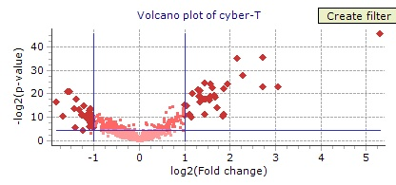
B.
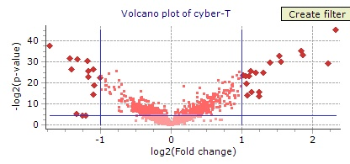
Figure 1. Log 2 Volcano plots for microarray chipsets of salamander liver tissue treated with 50 ug/L aqueous CdCl₂. Plot a. represents the control and 12 hour exposure chip set comparison. Plot b. represents 1 hour and 24 hours exposure chip set comparison. Dark diamonds represent candidate genes that are significant at p > 0.05 and greater than 2 fold expression.

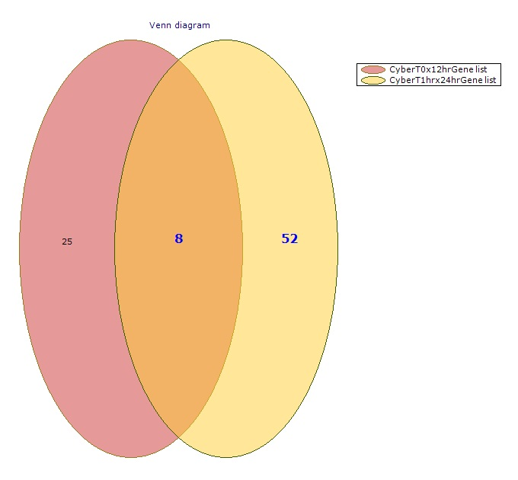
Figure 2. Venn diagram of gene lists developed from Cyber-T comparison of means from analysis of time point microarrays of cadmium treated (50 ppb) salamander livers. Comparisons are 0 hours X 12 hours and 1 hour X 24 hours.

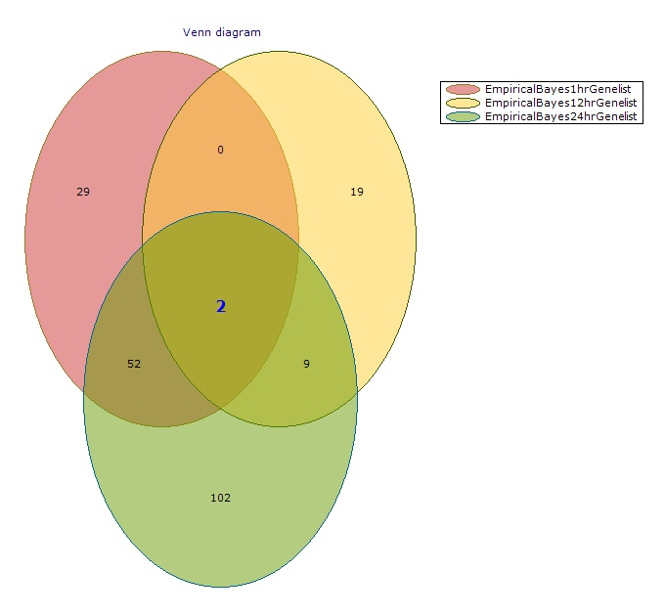
Figure 3. Venn diagram of gene lists developed from Empirical Bayesian analysis of time point microarrays of cadmium treated (50 ppb) salamander livers.

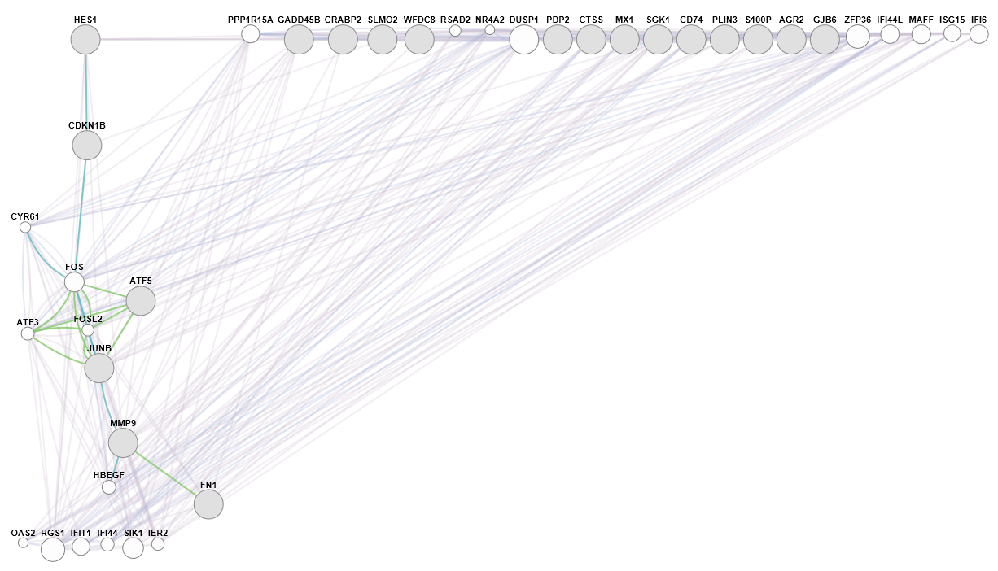
Figure 4. Protein Regulatory Network Map Produced using GeneMania software. Network shows conservative comparison of 0 hour by 12 hour microarray technical replicates. Green lines represent shared protein domains, dark blue lines represent a shared pathway, light purple lines represent co-expression and light grey lines represent co-localized genes.

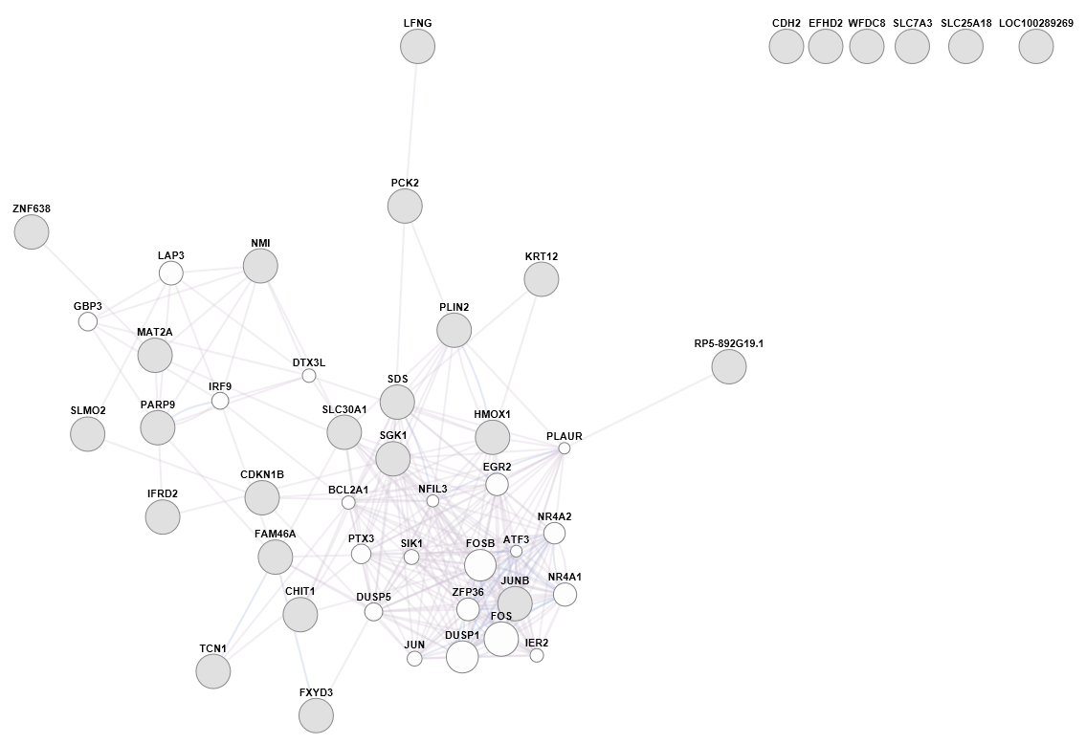
Figure 5. Protein Regulatory Network Map Produced using GeneMania software. Network shows conservative comparison of 0 hour by 12 hour microarray technical replicates. Green lines represent shared protein domains, dark blue lines represent a shared pathway, light purple lines represent co-expression and light grey lines represent co-localized genes.

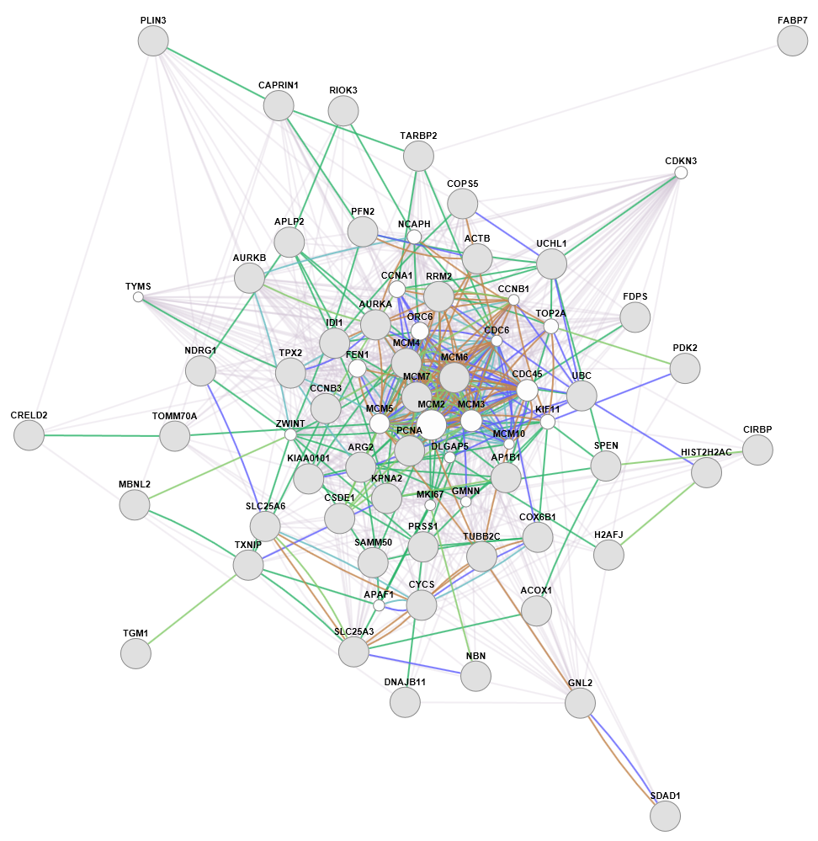
Figure 6. Protein Regulatory Network Map Produced using GeneMania software. Network shows non-conservative comparison of 0 hour by 1 hour microarray technical replicates. Green lines represent shared protein domains, dark blue lines represent a shared pathway, navy blue lines represent physical interactions, light purple lines represent co-expression, brown lines represent predicted pathways and light gray lines represent co-localized genes.

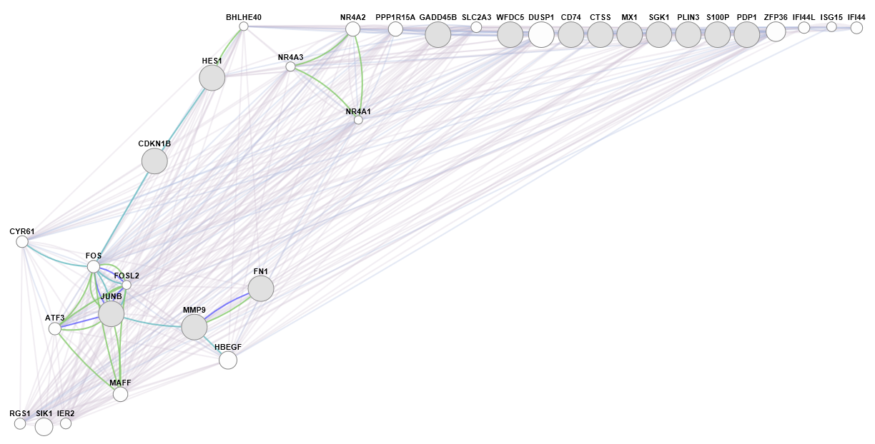
Figure 7. Protein Regulatory Network Map Produced using GeneMania software. Network shows non-conservative comparison of 0 hour by 12 hour microarray technical replicates. Green lines represent shared protein domains, dark blue lines represent a shared pathway, navy blue lines represent physical interactions, light purple lines represent co-expression, brown lines represent predicted pathways and light gray lines represent co-localized genes.

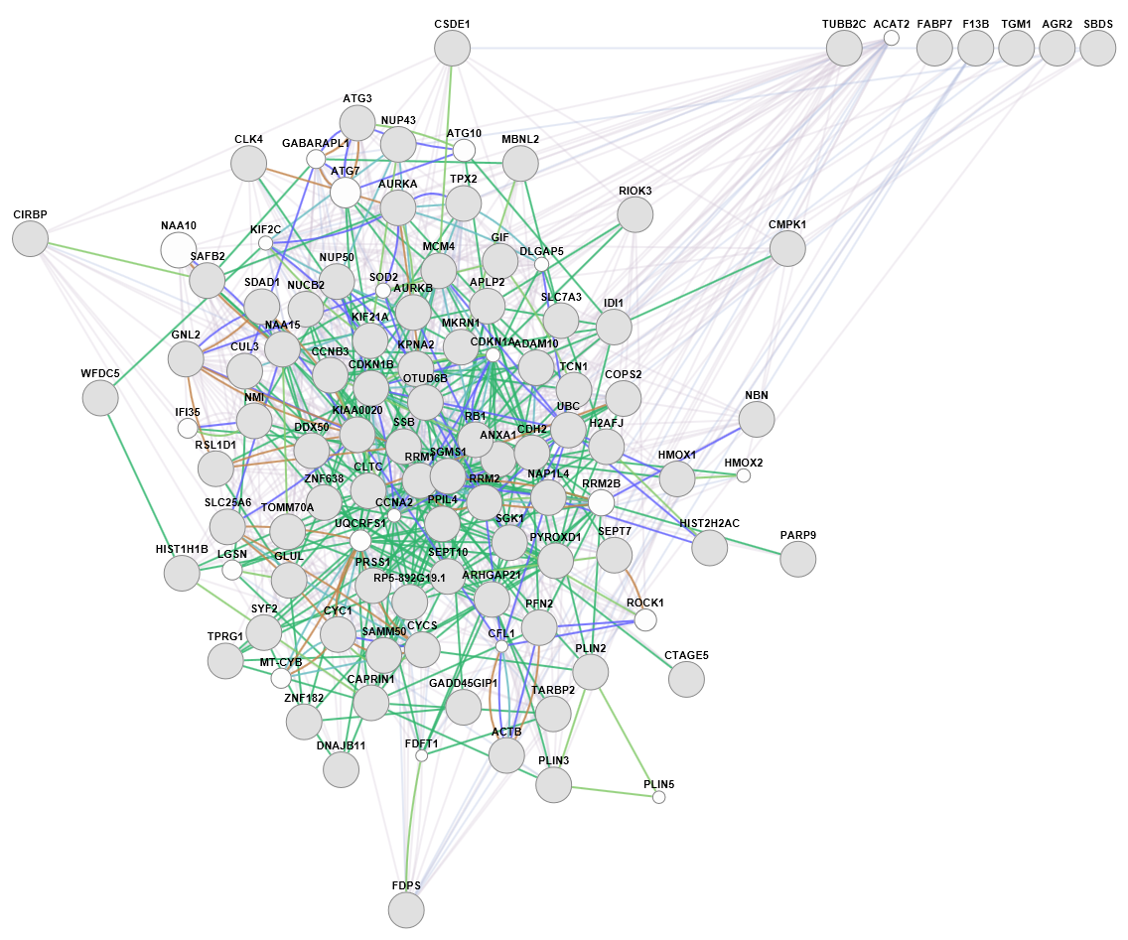
Figure 8. Protein Regulatory Network Map Produced using GeneMania software. Network shows non-conservative comparison of 0 hour by 24 hour microarray technical replicates. Green lines represent shared protein domains, dark blue lines represent a shared pathway, navy blue lines represent physical interactions, light purple lines represent co-expression, brown lines represent predicted pathways and light gray lines represent co-localized genes.

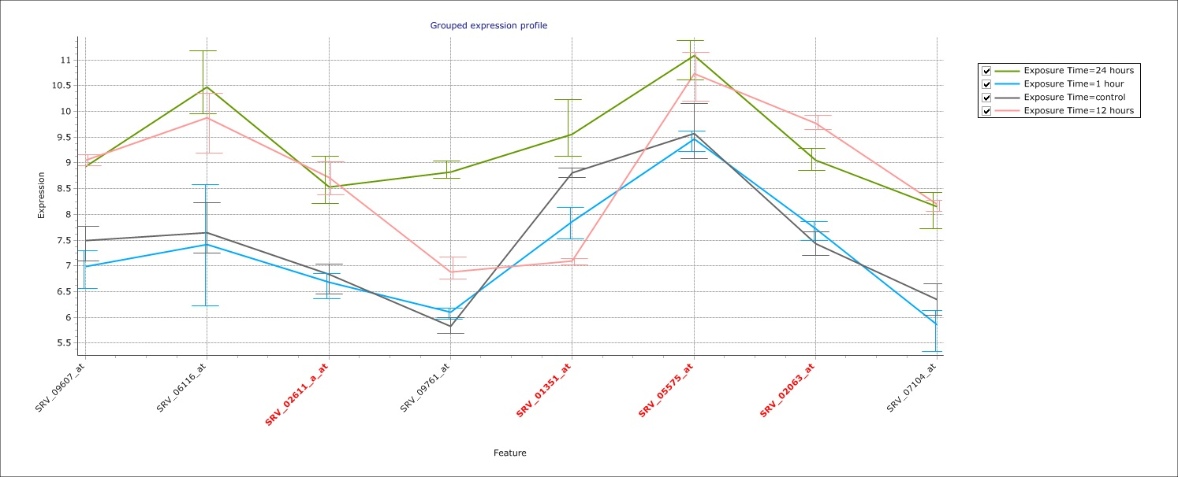
Figure 9. Grouped expression plots for genes shared between 0 x12 hours and 1 and 24 hours time points for Cyber-T statistical assessment of salamanders treated with 50 ppb cadmium. Red type names represent known genes. Error bars represent standard deviation.

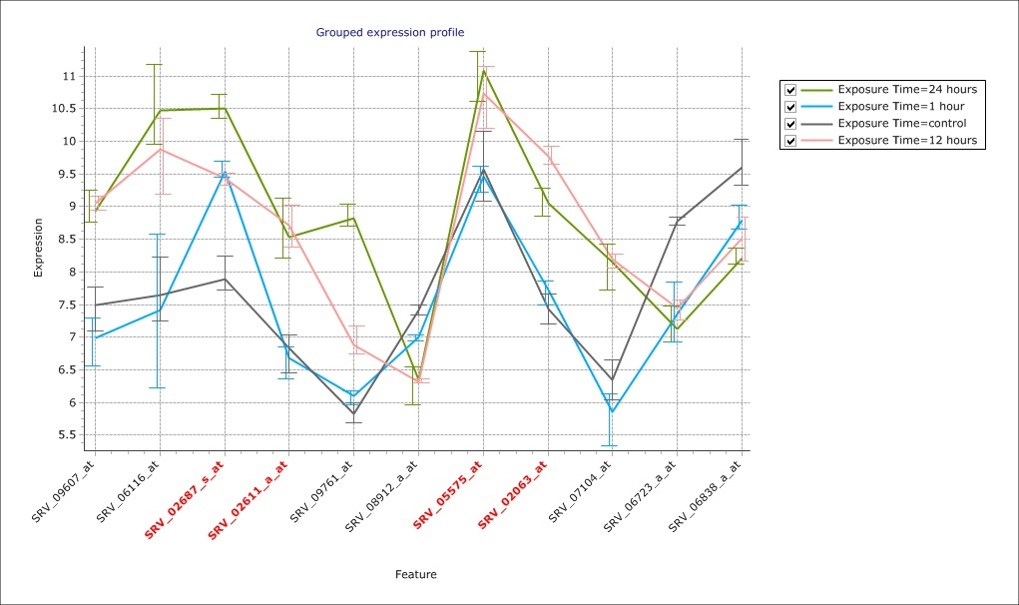
Figure 10. Grouped expression plots for genes shared between 12 and 24 hour time points for Empirical Bayesian statistical assessment of salamanders treated with 50 ppb cadmium. Red type names represent known genes. Error bars represent standard deviation.

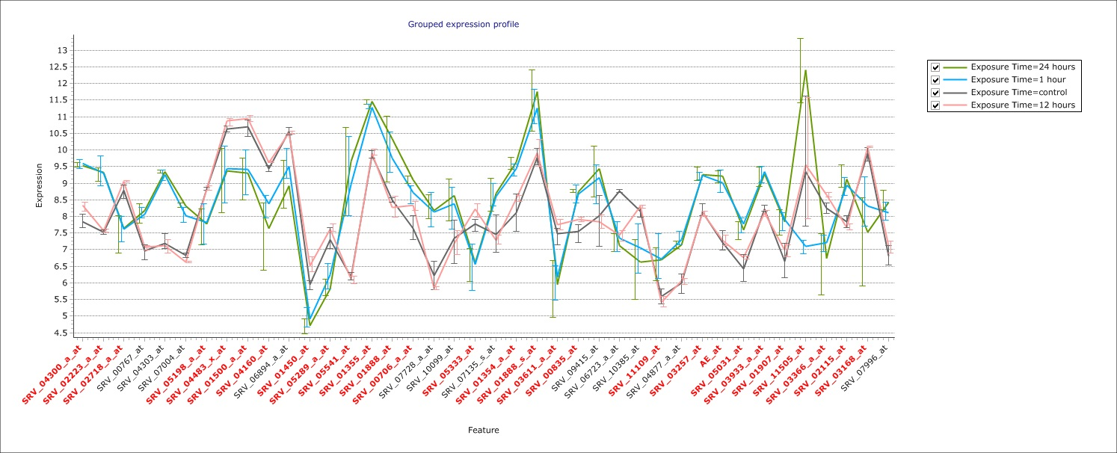
Figure 11. Grouped expression plots for genes shared between 1 and 24 hour time points for Empirical Bayesian statistical assessment of salamanders treated with 50 ppb cadmium. Red type names represent known genes. Error bars represent standard deviation.

Table 6. Q-PCR Primer Sets for Candidate Genes Responsive to Cadmium exposure
Sequence Name | Bases | Sequence
JunB Proto Axo Set 3 Forward P | 24 | TGA GTC TTA GCC TGT CAG CAC CAT
JunB Proto Axo Set 3 Reverse P | 24 | ATT CTG GAT GAT GAG GCG CTC CAA
S100 CalciumBindPAxo Set 2 For | 24 | TGC GAA GAT GAC TGC CGT AGA ACA
S100 CalciumBindPAxo Set 2 Rev | 24 | GAA GGC ATG GCT GTG GTT TGC ATT
SerumglucocorticoidAxo For | 24 | AGC AGA ACA GCA CAA CGT CTA CCT
SerumglucocorticoidAxo Rev | 24 | CTG GGT CAA AGT GCT GCA AGT CAT
CyclinDepKinaseAxo Set 1 Forwa | 24 | ACG TGC AGG AAT CTC TTC GGC TTA
CyclinDepKinaseAxo Set 1 Rever | 24 | TAC ATC GCC CTG GTT CGA AAG GAA
MMP9 Set 1 Forward Primer | 24 | AAA CTG CAA GCA CAG AAG TGT GGG
MMP9 Set 1 Reverse Primer | 24 | TGG ATC AGG TGG GCT ACG TGA AAT
JunB Set 1 Forward Primer | 24 | TCC ACC TCG GCT TTC AAG GAA GAA
JunB Set 1 Reverse Primer | 24 | AGA AAT GCA GCT GCT GAT GTT GGG
SGK1 Set 2 Forward Primer | 24 | TTG CTA ACG CCC ATT TCC AGA TGC
SGK1 Set 2 Reverse Primer | 24 | ACA CAC CCT CTA TTG ACC CAA GCA
CDKN1B Set 1 Forward Primer | 24 | TTT CGG TCC CAT TGA CCA CGA TGA
CDKN1B Set 1 Reverse Primer | 24 | AGC ATC AAT TGT TGG AAG CCA CCC
HMOX1 Set 1 Forward Primer | 24 | AGC AGG CAG AAG ACA CCG AGT TTA
HMOX1 Set 1 Reverse Primer | 24 | ATT GGA ACC GTG GAT GGA GGA AGT
AF008583 metallothio -119F | 20 | GCA AGT GCA CAT CCT GCA AA
AF008583 metallothio -187R | 21 | CCT GGC CAC ACT TCT CAC ATT
MC02958 Hsp70-90 Org prot-879F | 23 | CAT TAG GGC GAT GTA CGA AAC TG
MC02958 Hsp70-90 Org prot-950R | 21 | GCC ATT GTC CAA GGA TCT TGA
Reference genes
TC00445 - beta actin-568F | 24 | CAG TGC CCA TCT ATG AAG GTT ATG
TC00445 - beta actin-636R | 20 | GAT CAC GAC CAG CCA AGT CA
TC00760GAPDH-99F | 18 | CGC ATC GGT CGT CTT GTG
TC00760GAPDH-159R | 18 | TGG CCA CCA CGG ACA CTT

